Change Your Password in Workday

1. Click on the **Icon** in the top right corner of Workday beside your name

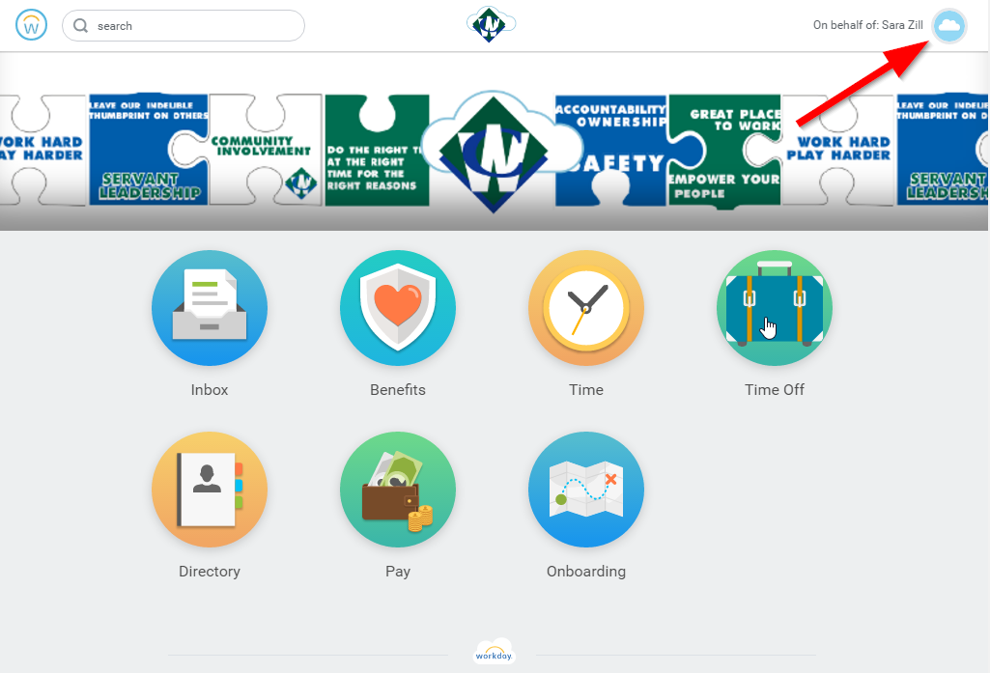

1. A drop down menu will appear, click on **My Account**

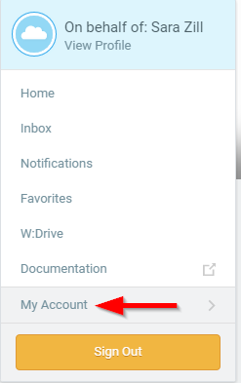

1. Select **Change Password**

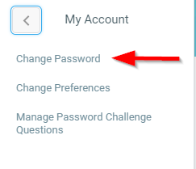

1. Complete the steps to change your password

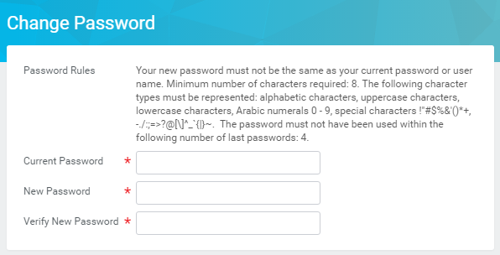

1. Click **OK**

